Tanmay Fadnavis

SUID: 971141760

Computer Security

Lab-8

# TASK 1: SQL INJECTION ATTACK ON SELECT STATEMENT

The screen shots for task-1 are below.

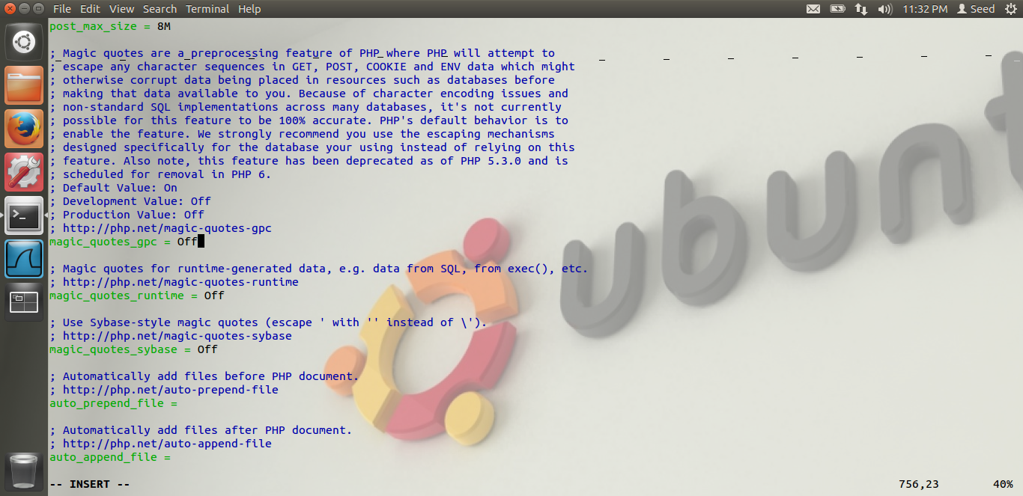

In the above screen shot, we can see that I have turned off the counter measure of magic_quotes_runtime. Its value is off.

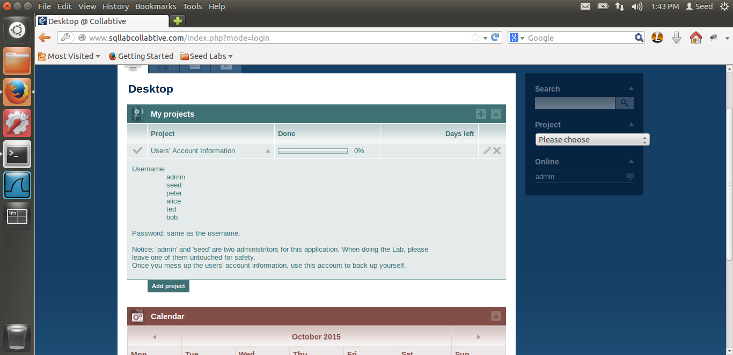

Here, I logged in as admin, and we can see the various users, like alice,peter,ted and bob.

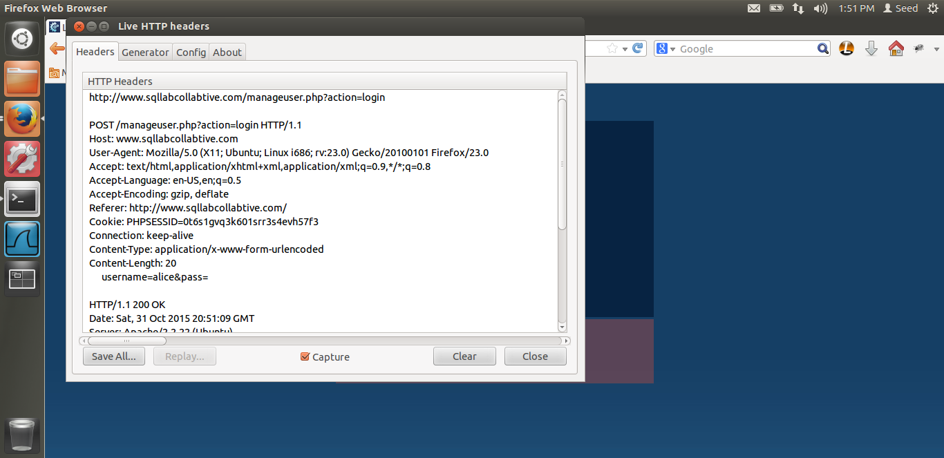

Above is the screen shot for the liveHttpHeader when the user logs in. Now let us see how to exploit the SQL injection.

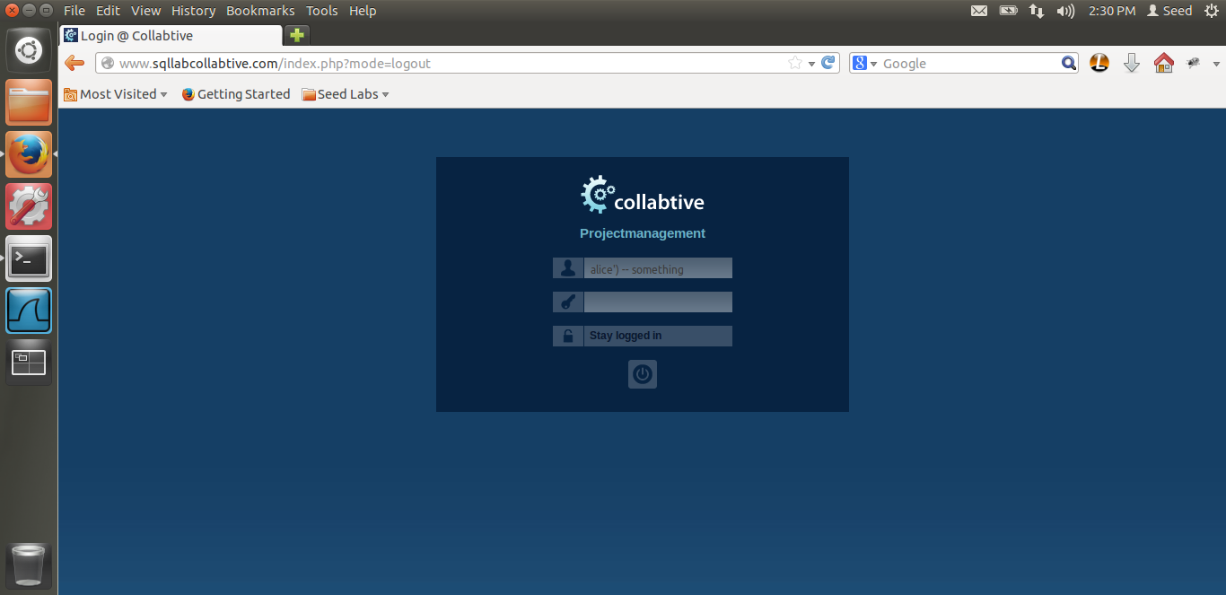

As you can see in the screen shot, I have exploited the vulnerability. If we type the below code,

**Alice’) -- something**, we login to alice’s account . The reason is, if we see the query in the code, as given in the lab,

===========================================================================

$sel1 = mysql_query ("SELECT ID, name, locale, lastlogin, gender,

FROM USERS_TABLE

WHERE (name = ’$user’ OR email = ’$user’) AND pass = ’$pass’");

$chk = mysql_fetch_array($sel1);

if (found one record)

then {allow the user to login}

Here, in the above query, there is an SQL injection. Thus, if I put any username and comment out the password, the database will return 1 single record. And even if there is a single record, the user is authenticated. Thus, due to miss formation if the query, we are able to login as alice without using any password. In my attack, alice’) – comment, thus, the username is alice. Then I am closing the bracket for the syntax to be complete, then I am using the SQL comment, “--“ and then I am typing just comment/something in this case. This is necessary because as per the SQL comments docs, we need to have 1 character, a whitespace or some character to be recognized as a comment. Thus, the query will fetch username alice and comment out rest of the query. Thus we are exploiting the SQL injection and the attack is successful.

Also, in the code, we can see that,

// $user = mysql_real_escape_string($user);

// $pass = mysql_real_escape_string($pass);

The above 2 lines have been commented, thus the counter measure mysql_real_escape_string has been commented out, hence our SQL injection works. This countermeasure is discussed in more detail in the countermeasures task.

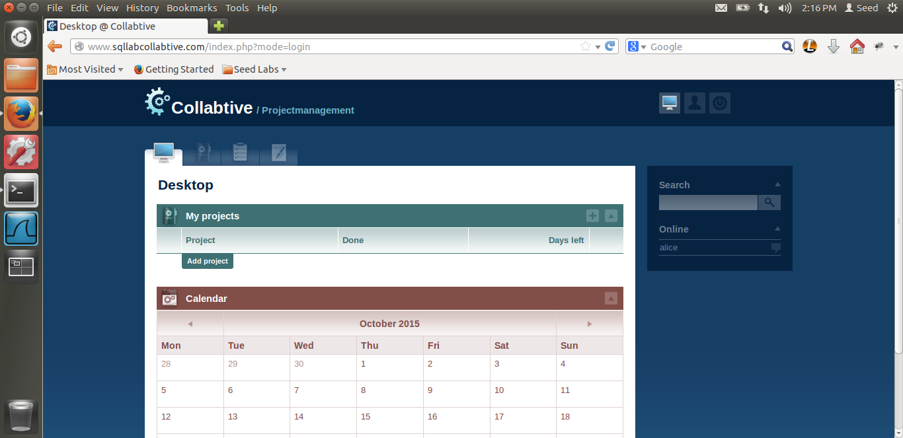

This is the screen shot, where we can see that the attack is successful. Reason is mentioned as before.

Also, below is another SQL attack.

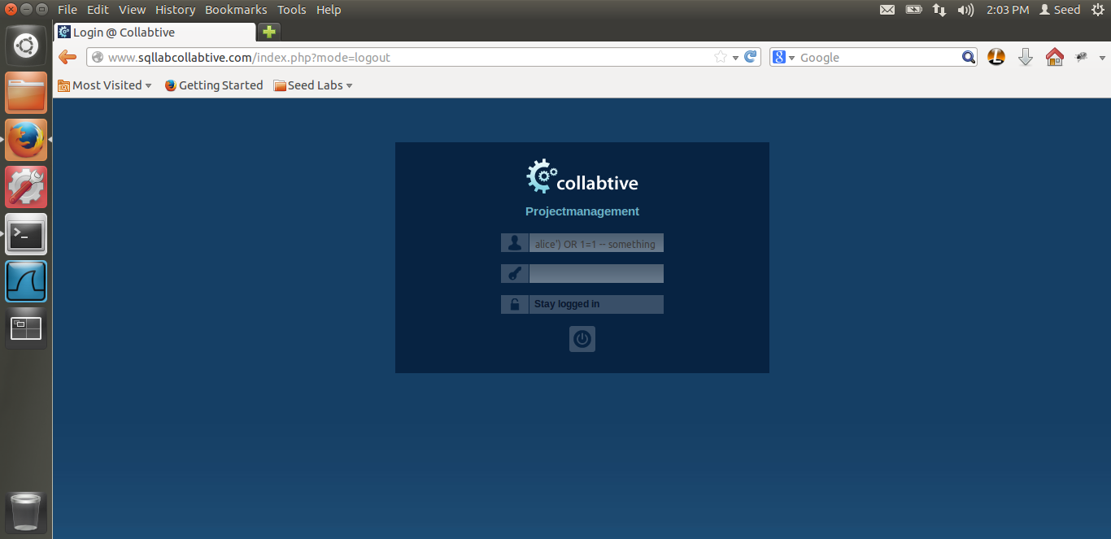

Thus, in the screen shot, we can see that the code I have written as,

Alice’) OR 1=1 – something.

This will return the topmost account in the database, i.e. we will login to the first result/user who’s result is returned by the query because of 1=1 condition which will always be true. In our case, admin is returned. Thus, we are able to login to the admin’s profile. Below is the screenshot.

The reason is the same as above.

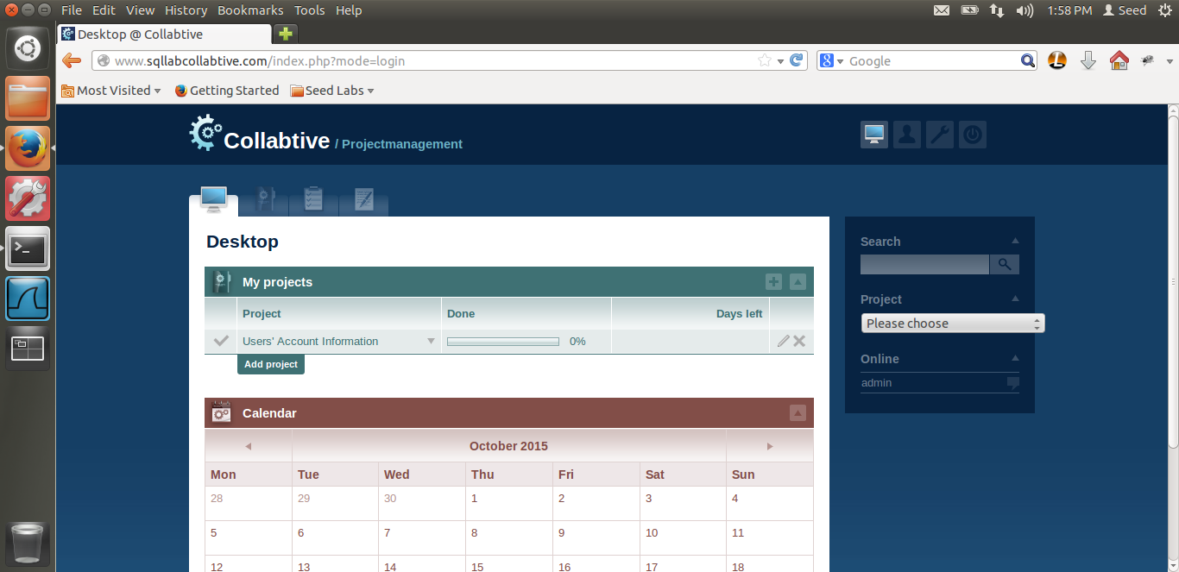

This is the admin’s front page, as we can see all the user’s account information.

Task 1.2

In this task, we have to check whether we can modify the database, i.e. use an update statement.

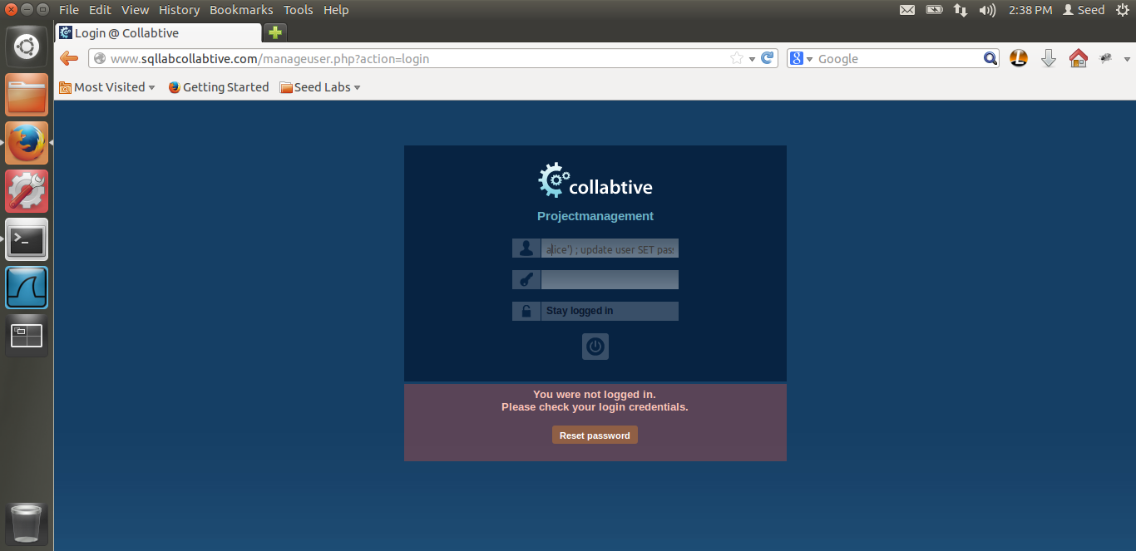

Above is the screen shot of the attack I have tried. Thus, by using the ; semi-colon, we can run multiple queries in SQL. Hence, I tried using this technique to execute the update statement, by running the command,

**Alice’) ; update user SET pass=’123’ where name=’ted’**.

But as seen in the screen shot, this gives the error that you were not logged in, basically, authentication error. Thus, the attack is not successful.

Reason is, mysql_query supports just a single query. It does not support multiple queries. Thus, even though we execute the update query after the semi-colon that is not executed. Hence, our update attack is not successful.

# TASK 2: SQL INJECTION ON UPDATE STATEMENT

The screen shots for task-2 are below.

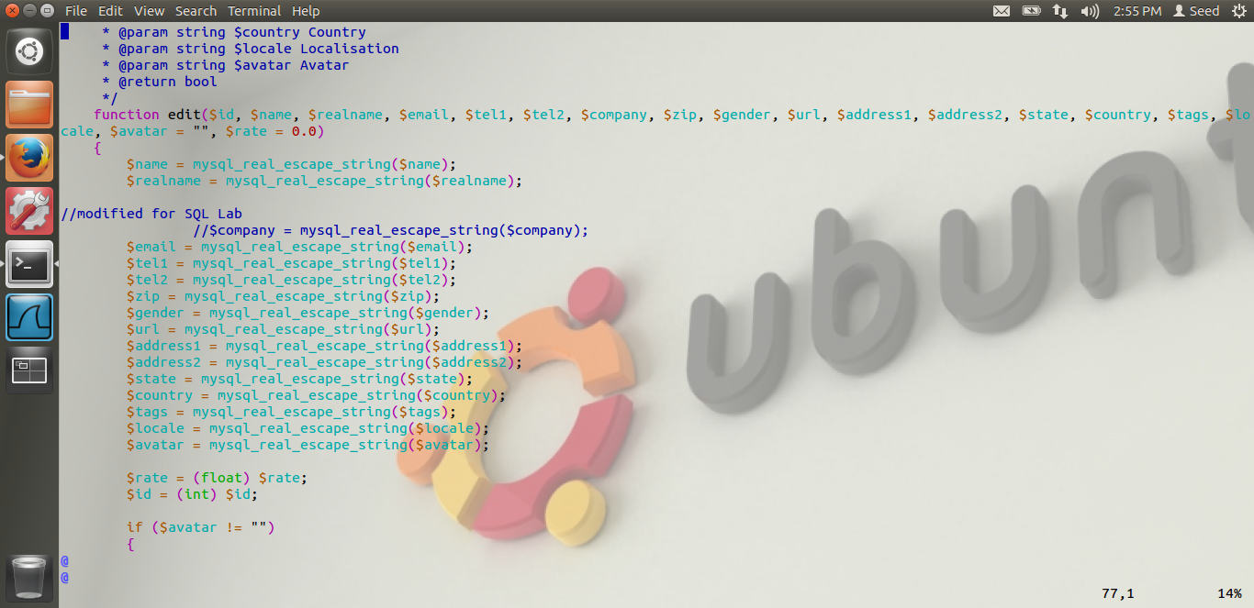

Here, I have put the screen shot of the edit function, this is the function called when the user edits the profile. From the above screen shot, we can see that the $company has been commented, i.e. there is a SQL vulnerability in the $company variable which corresponds to the company field in the GUI.

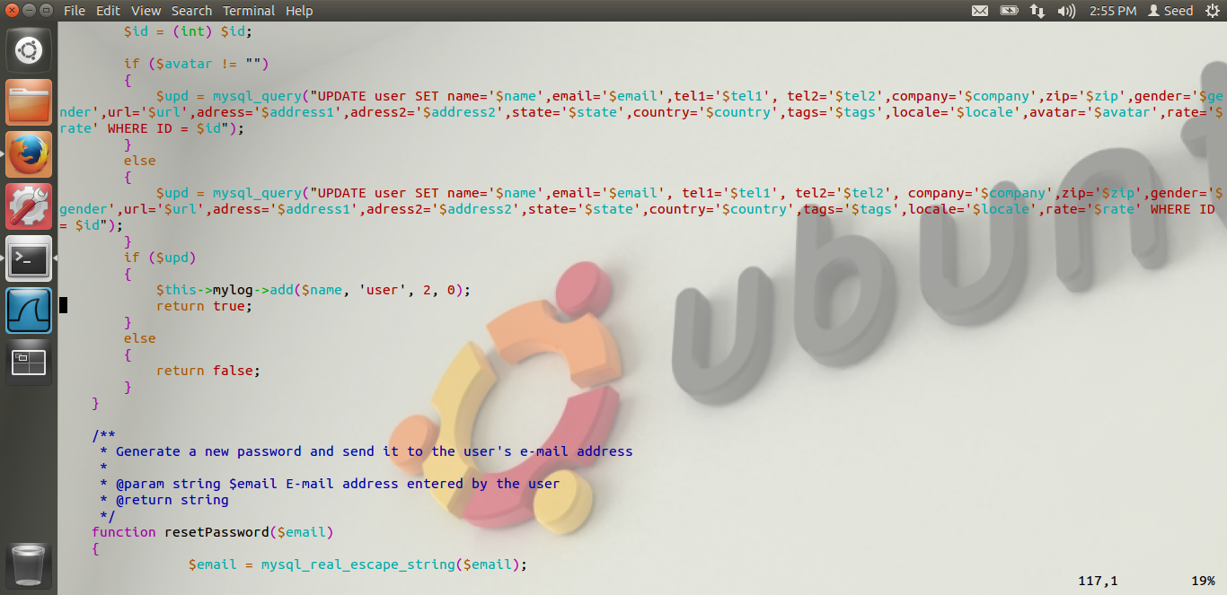

Thus, we see that there is an update statement which updates values in the user field. In this update statement, if we exploit the vulnerability in the $company variable, we can update other user’s password, I am updating ted’s password and updating the table. Let us see how.

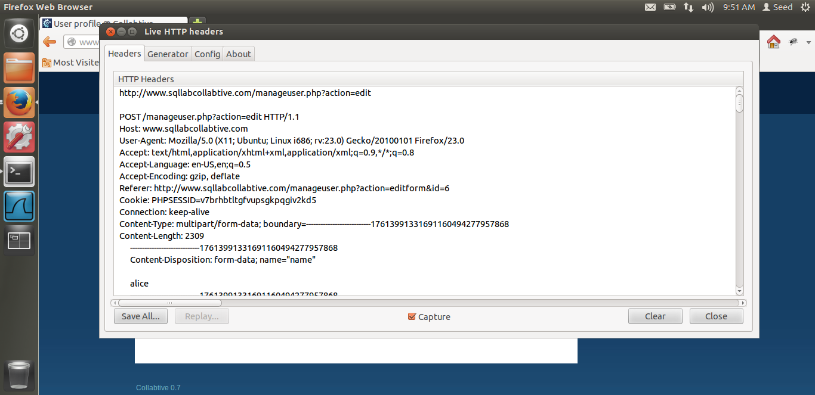

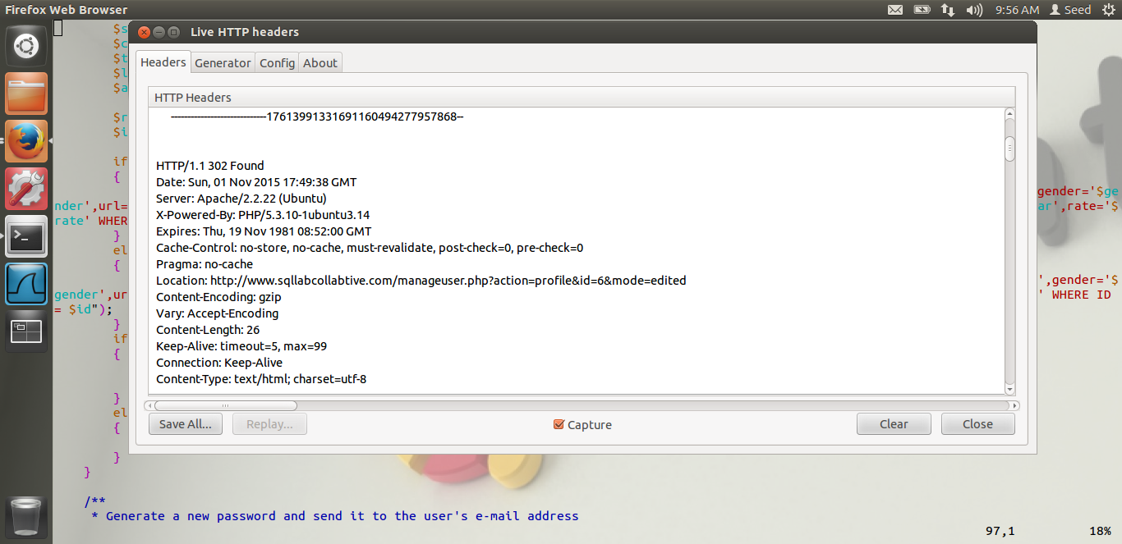

In the above screen shots, we can see the HTPP header which is sent to the server when the profile is updated. Thus, using this, I see that the name, id and rest of the details are being sent. Hence, if I will have to update the name of the user too, i.e. ted in my case, to change the password for ted.

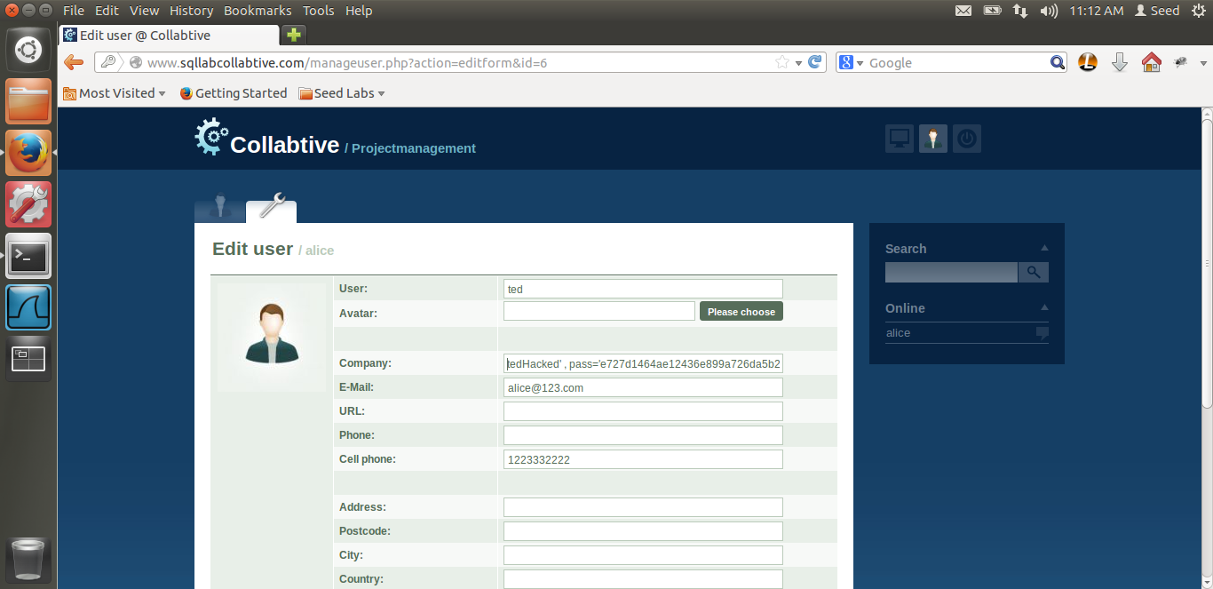

Thus, in the above screen shot, we can see that, I am updating the company field. I have logged in as alice. But I am exploiting the SQL injection in the company variable as explained before. Now, in the compay variable, I am putting the value as tedhacked’ and then updating the password, i.e pass and putting the sha encryption of ‘mypass’. The reason I am putting sha encryption is, in the code, we can see that, the password is sha encrypted and then checked against the database.

**$pass = sha1($pass);**

This is the line which does the sha encryption. Hence, I used an online sha encryptor, and found out the sha encryption of ‘mypass’ which I am updating in the database. Also, we can see that, in the name field, the user I am putting it as ‘ted’, the reason is, even the name is being updated.

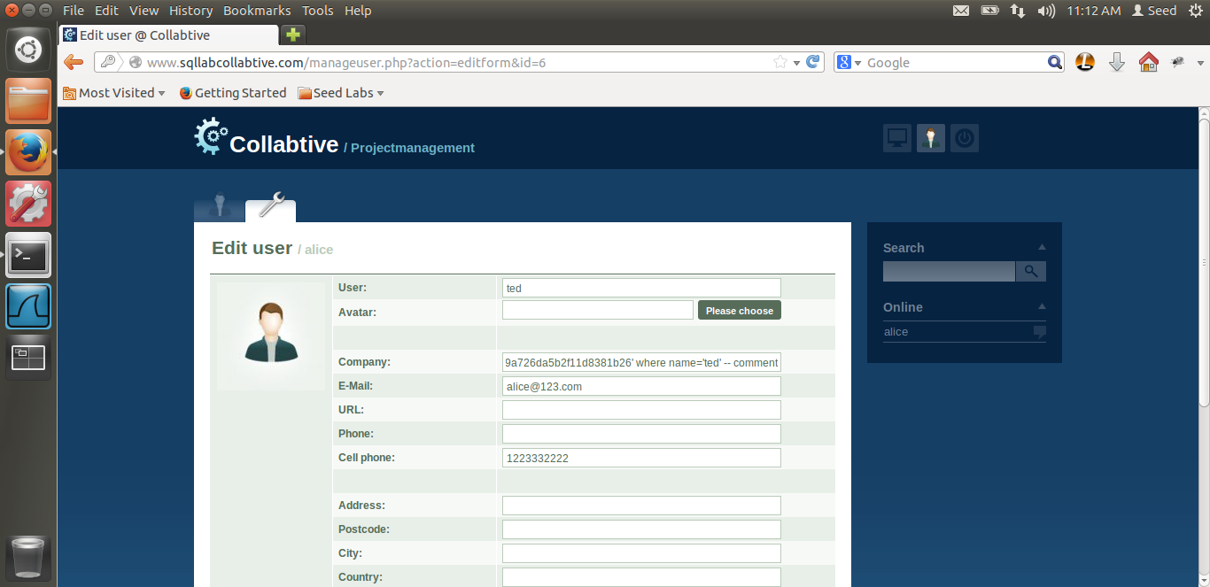

In this, we can see that the query end with, where name=’ted’. Thus, the full command is,

**tedHacked’, pass=’e72348gkghdf9459845rhfh4095845’ where name=’ted’ – comment.**

Thus, in this, the first field the is company update, which is tedHacked’ in our case, Then I am updating the password in an encryption, i.e. sha encryption, where name=’ted’ and then I am commenting the rest of the query. What this will do is, it will update ted’s password with our password, i.e. the attacker’s password, and thus the SQL injection update query is successful. Let us login to ted and see what happens.

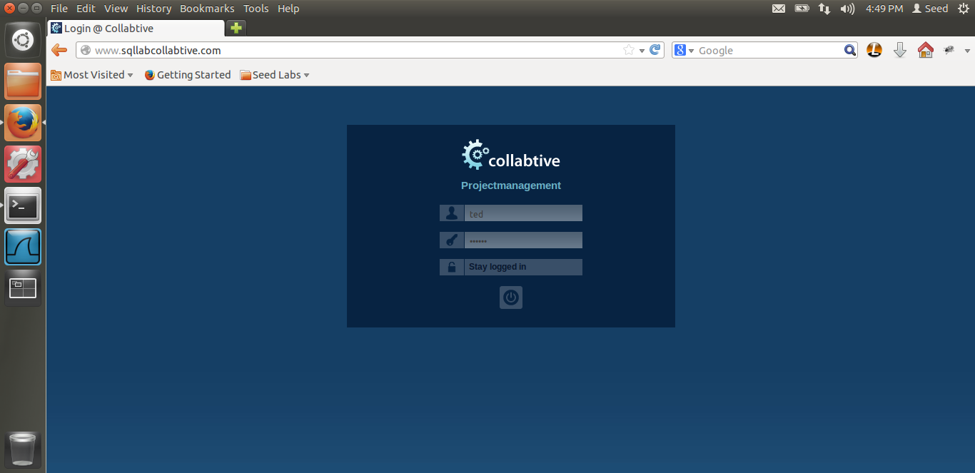

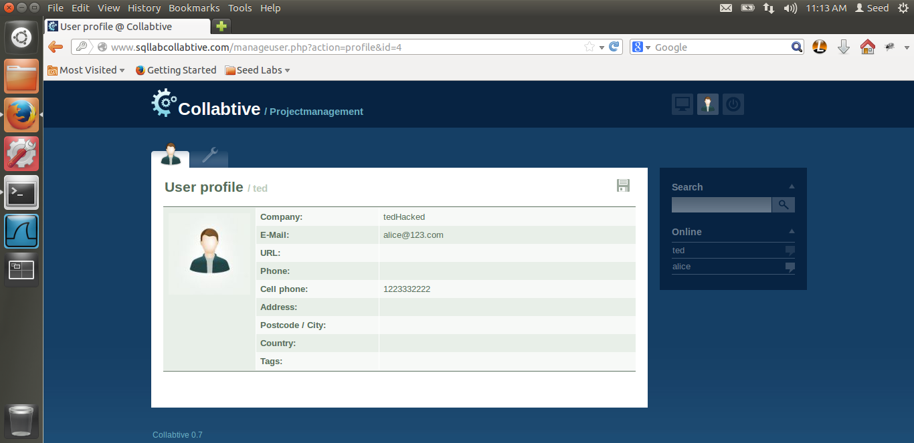

After we login to ted, using the password, ‘mypass’, whose encrypted value we had stored in the database, we are successfully able to login. Thus, after we login, we can also see that, in the company Field, our value ‘Ted Hacked’ comes as soon as the profile is loaded. Thus, this also proves that our update was successful.

Thus, I have shown SQL injection on UPDATE statement.

# TASK 3: COUNTERMEASURES

The screen shot for Task-3 are below.

3.1 Escaping special characters using magic_quotes_gpc.

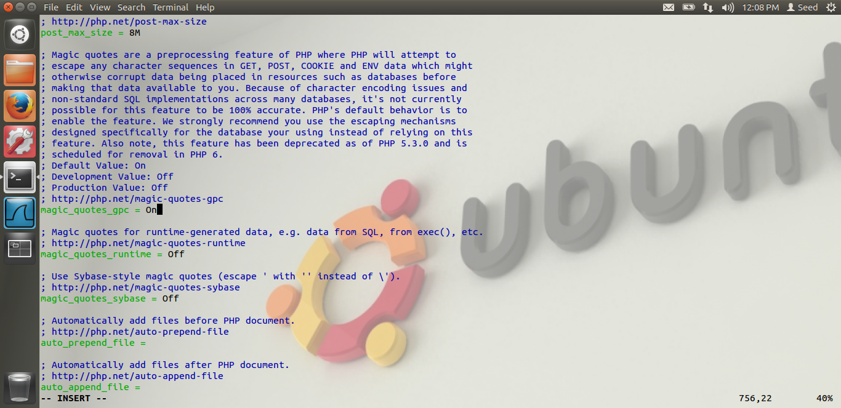

As we see in the screen shot, I have turned on the magic_quotes_gps countermeasure.

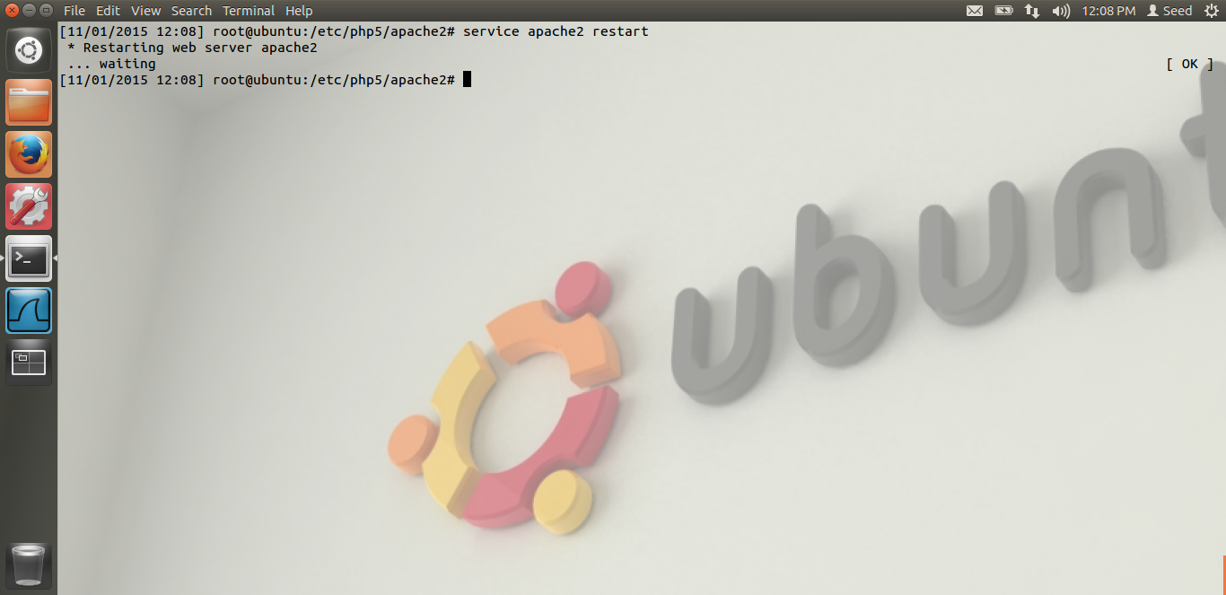

In the above screen shot, we can see I have re-started the server.

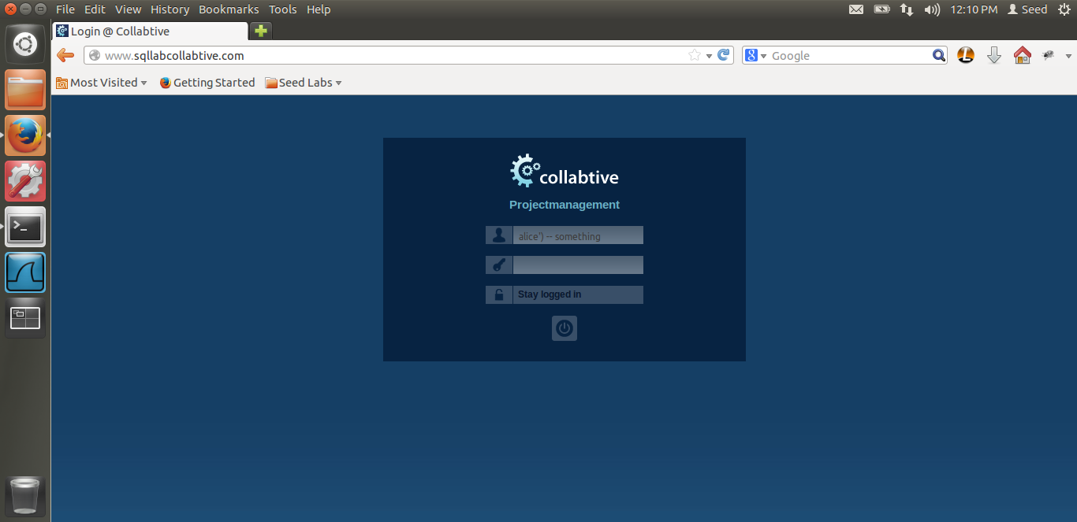

This is the same attack which I did in the first task, which is exploiting the SQL injection vulnerability. Let us see what happens.

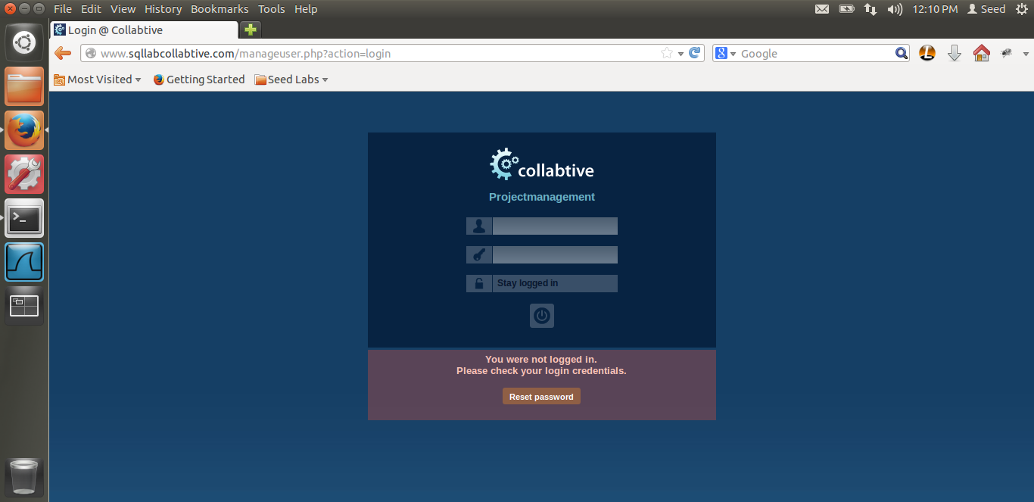

As you can see, after turning the countermeasure on, the attack is not successful, i.e. even though there is a vulnerability, we are not able to attack the system.

Reason: As mentioned in the lab, in the code where name=’user’ the single quotes tries to separate data in user variable from code. Therefore, the magic_quotes_gps is a mechanism which basically adds a backslash \ before the single quotes. PHP provides mechanism to basically add backslash before both the single and double quotes. This mechanism is magic_quotes_gpc. Thus, this mechanism by adding backslash in our example, before alice\’, it treats our entire string as username and hence the attack is unsuccessful.

3.2 Escaping special characters using mysql_real_escape_string. The screen shots are below.

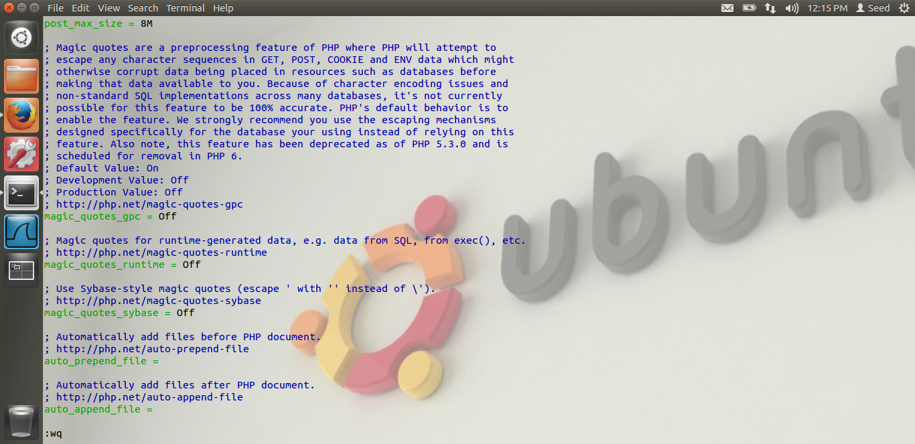

Here in the above screen shot, as mentioned in the lab, I have again turned off the magic_quotes_gpc.

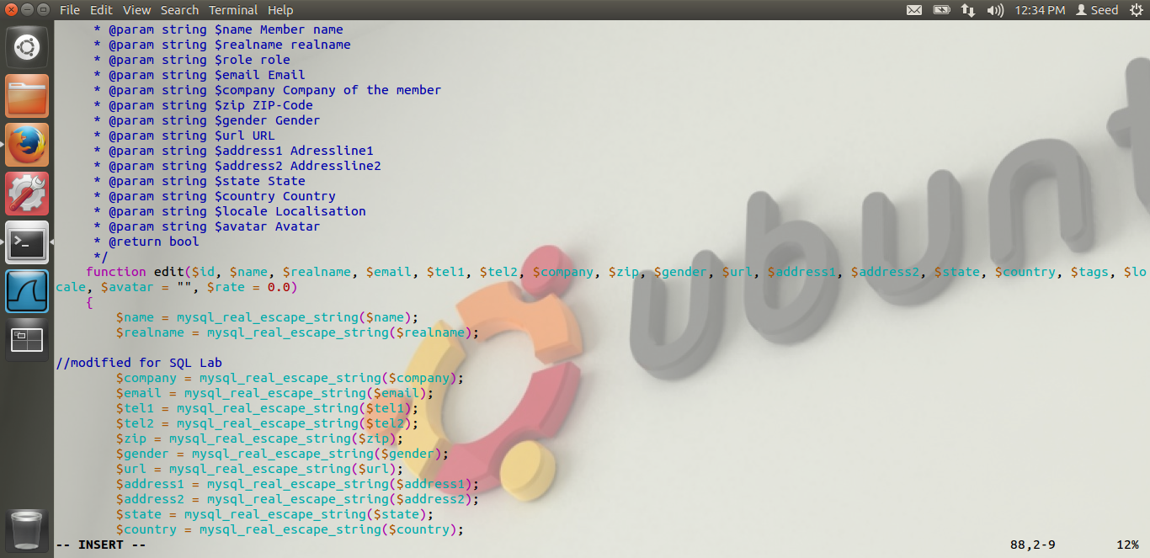

As you can see in the screen shot, I have uncommented the line, which was commented for the variable $company. Thus, even the variable company does not have the SQL injection which it had in the task-2.

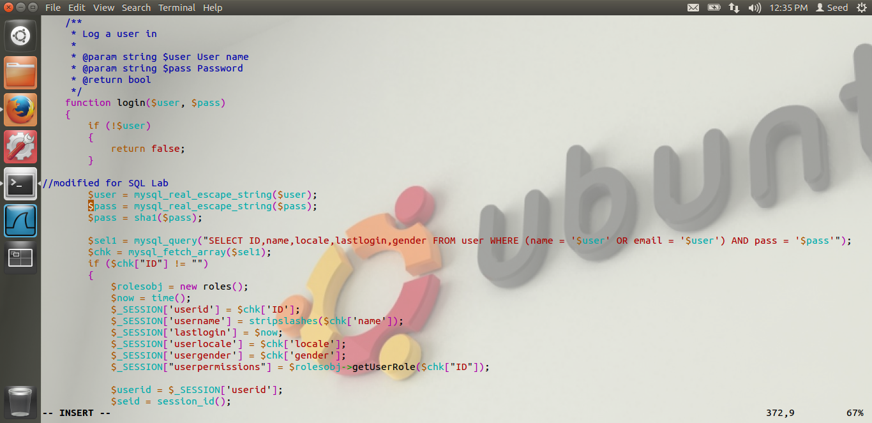

In the above screen shot, we can see that I have uncommented the lines, for the variables $user and $pass, which were originally commented for the task-1. Thus, even the login does have the mysql_real_escape_string protection.

Now let us try to attack and lets see what happens.



Thus, as you can see that the attack is unsuccessful, due to the counter measure we have used.

Reason: Basically, this is the same countermeasure as before, but this is a database specific escaping mechanism instead of magical_quotes. Even this mechanism prepends backslash before special characters same as before and thus gives the protection against the SQL injection vulnerability. Thus, alice’ ) will be backslashed and our attack will fail. Hence we are not successful in our attack.

3.3 Prepare statement.

The screen shots for task 3.3 are below. Basically, the prepare statement is the SQL’s logic to separate data and code. The main issue in SQL injection is that the data and the code part are mixed together. Hence, the SQL database is not able to tell the difference between the two, and the attacker can exploit this vulnerability to do SQL injection. The prepare statement separates data and code. We will see how.

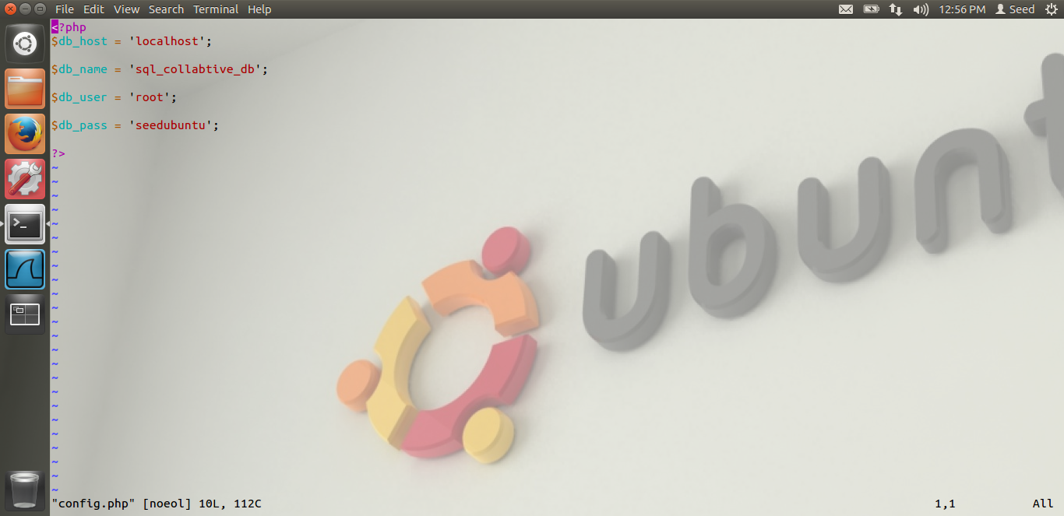

The code given by Dr Du in the lab, for the mysqli, we need 4 information, db_host, db name, db user and db password to connect to the database. This information for our sql_collabtive_db is present in the config.php file. Above is the screen shot for the same.

Now, let us see the code which I have modified.

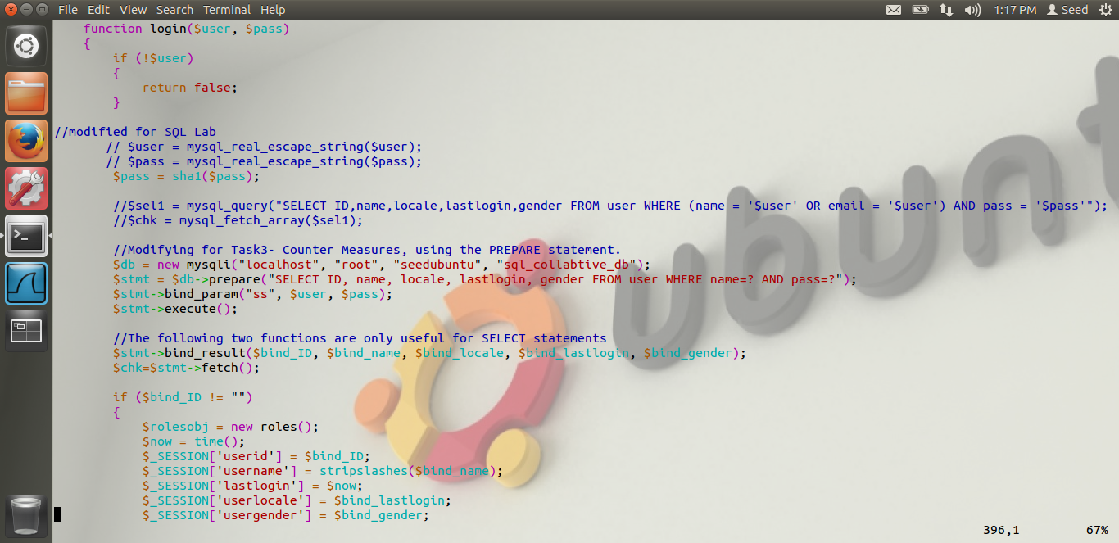

In the above screen shot, we can see that I have commented the old code. I have written a prepare statement. The parameters for mysqli are basically the authentication information. Then I am preparing a prepare statement, and the data is name=? and pass=? In the bind param, the first argument is “ss”, i.e. both the data are of string type, as our name and password is of string.

Once that is done, I am executing the query and fetching the results, basically binding the results in the bind_id,bind_name,bind_locale,bind_lastlogin and bind_gender parameters. Thus, in the original code, instead of chk[ID], now the result is in bind_id. Hence I am replacing the old chk’s value by these new values.

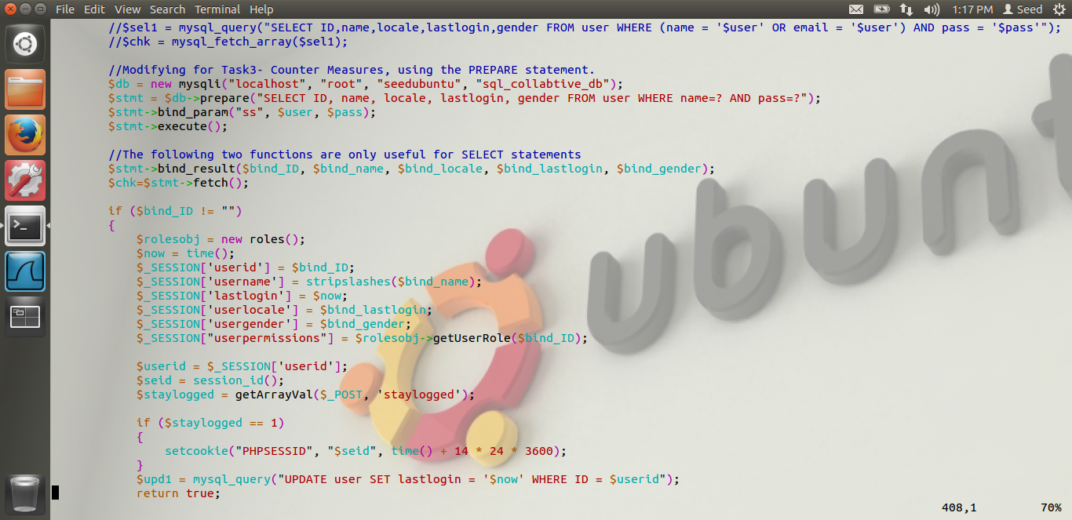

Here is the rest of the code, which I have explained above. Let us see what happens when we try to attack.

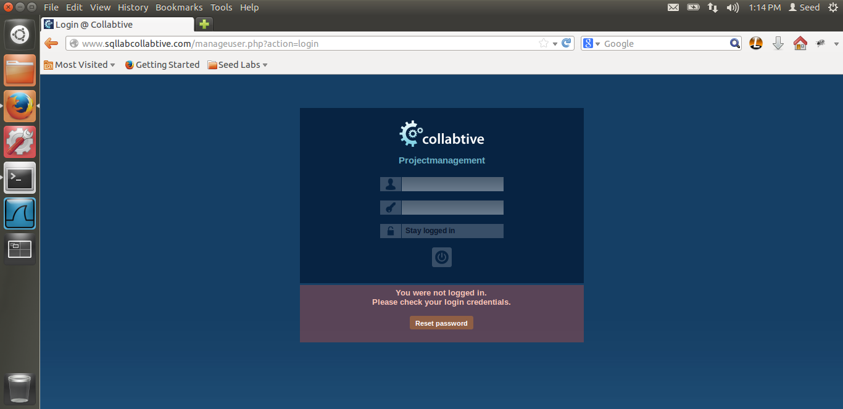

Thus, we get this login unsuccessful screen. This shows that the attack is unsuccessful. The reason is, prepare statement which we are using. It separates the data and the code, as explained above , the prepare statement will treat everything in the $name and $pass variable as data and not code. Hence, we are not able to execute the SQL injection attack. Thus, because of the prepare statement, the attack is unsuccessful.

Thus, I have completed Lab-8.